Portfolio Engels

Engels: 2020-2021

Name: Jason Ronoastro.

Class: LPIAO20A4.

Date: 30-09-2020.

Return date: 25-10-2020.

Assigments:

1. Mindmap 🡪 **Page 3**
2. Vocabulary city life/ My Hometown 🡪 **Page 4/6/7**
3. Hobbies 🡪 **Page 8**
4. **Mindmap:**



1. **Vocabulary city life/ My Hometown:**

|  |  |
| --- | --- |
| Vocabulary city life | 5 Sentences |
| * Cash machines | I’m going to get my money from the cash machine. |
| * Subway entrance | The man point his finger to the nearest subway entrance. |
| * Hospital | I broke my arm so my parents brought me to the hospital. |
| * City | Rotterdam is a city of South-Holland. |
| * Clinic | My dog is sick so they bring him to a clinic. |

***My hometown:***

My hometown is in Rotterdam. But I live on the south side of Rotterdam named Rotterdam-Zuid. Rotterdam is a big city and also a popular city because the harbor Rotterdam is the biggest harbor in Europe. Beside that it is also a popular tourist spot because of the big malls for example Zuidplein that’s a inside mall and Alexandrium that’s also an inside mall. And the big events that are taking place in Ahoy or in the centre of Rotterdam. Or the museums where you can see the history of Rotterdam because for example in the 2nd world war where Germany bombed whole Rotterdam. Rotterdam is also popular because of the two bridges that connect the north side of Rotterdam and the south side of Rotterdam. The two bridges are named: The Erasmusbrug and the Willemsbrug. Lombarijden is the town where I live in Rotterdam-Zuid. It have a small park called: Spinozapark and have a small shopping district on the spinozaweg where you can do your groceries and where you can eat.

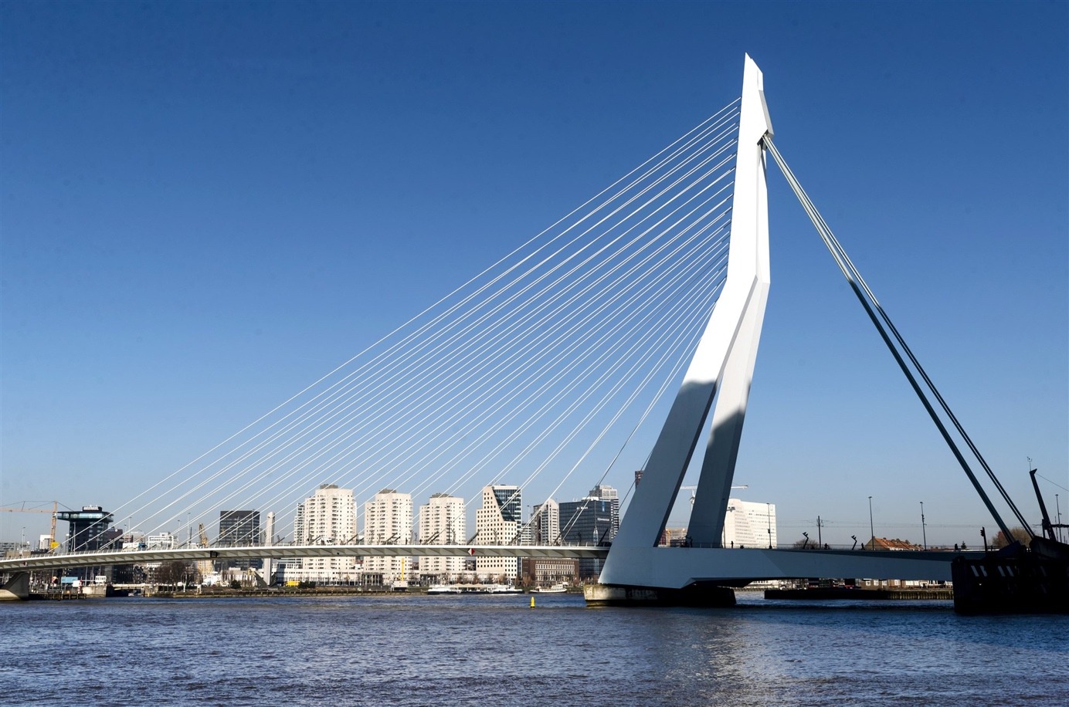

**Erasmusbrug^**

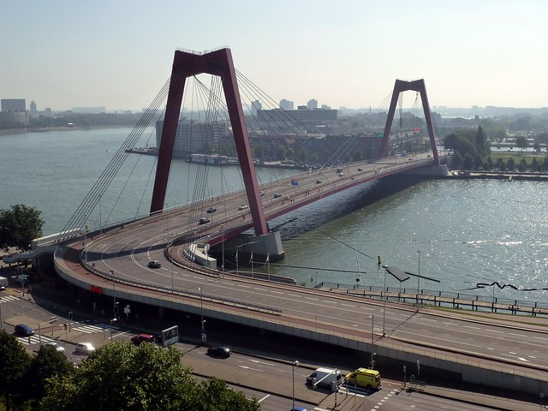

**Willemsbrug^**

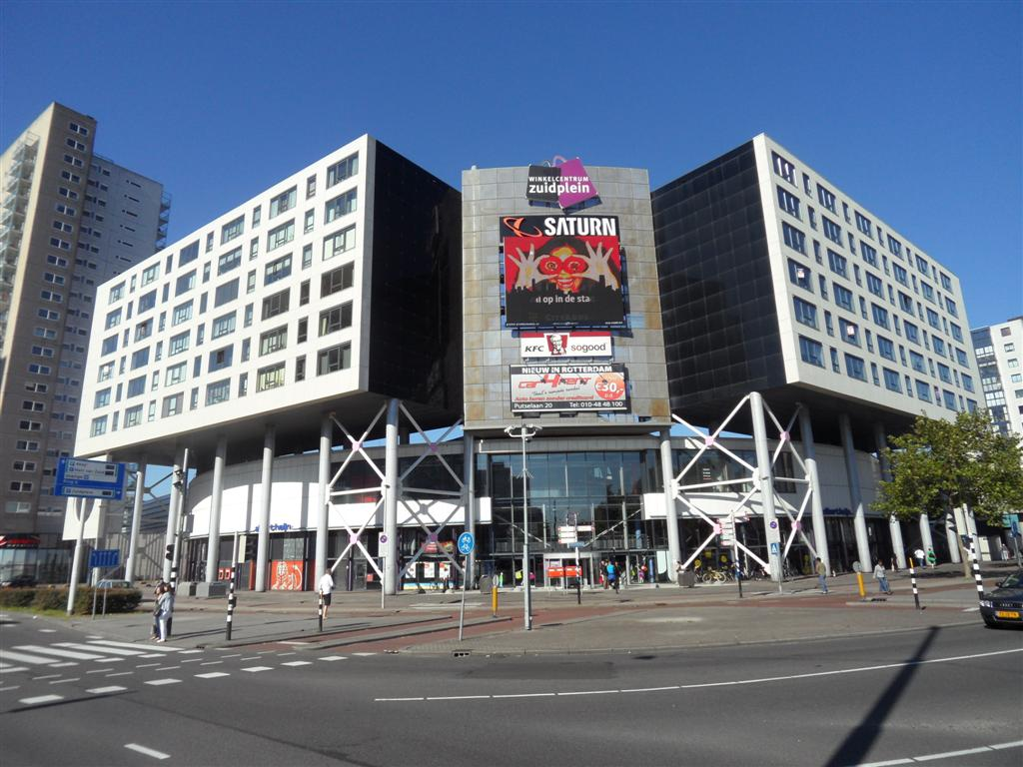

**Zuidplein^**

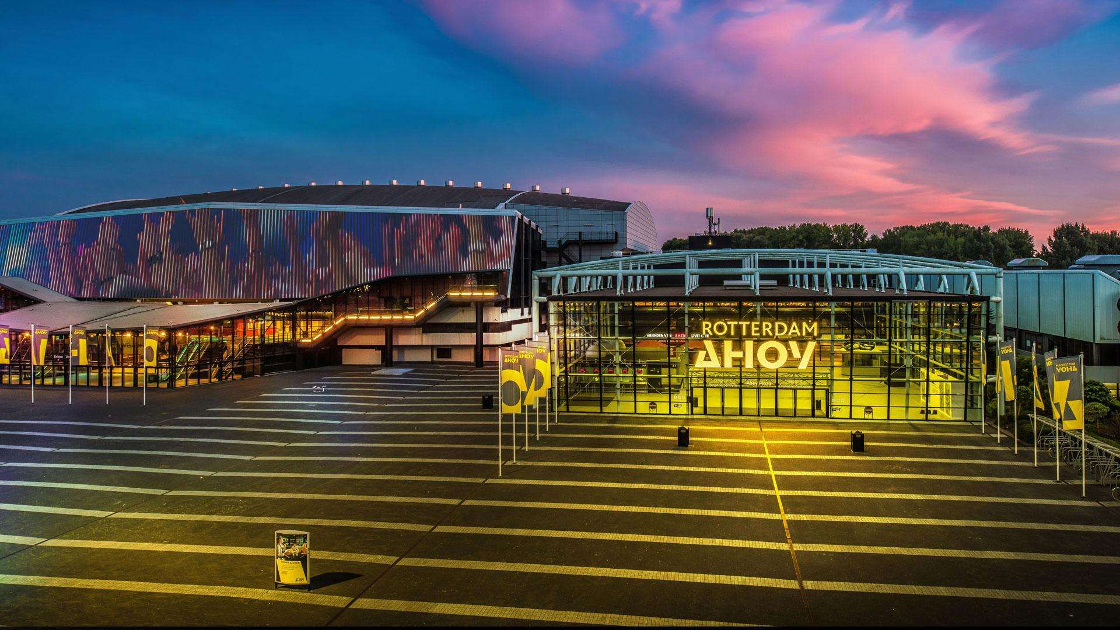

**Ahoy^**

1. **My hobbies:**

***Exercise 1:***

How many hobbies do I have:

1. Gaming.
2. Football.
3. Programming.
4. Watching series on Netflix.
5. Working.

***Exercise 2:***

**Click on the Word document below.!**



***Exercise 3:***

I don’t have a new hobby because I’m not looking for a new hobby maybe in the future.